Arene Ruthenium Catalyst MCAT-53 for the Synthesis of Heterobiaryl Compounds in Water through Aromatic C–H Bond Activation
Anita Mehta* , Biswajit Saha, Ali Aiden Koohang, and Mukund S. Chorghade
Chicago Discovery Solutions LLC, 23561 West Main St., Plainfield, Illinois 60544, United States
Org. Process Res. Dev., 2018, 22 (9), pp 1119–1130
DOI: 10.1021/acs.oprd.8b00141
Publication Date (Web): August 14, 2018
Copyright © 2018 American Chemical Society
*E-mail: amehta@chicagodiscoverysolutions.com.
Cite this:Org. Process Res. Dev. 2018, 22, 9, 1119-1130
Abstract
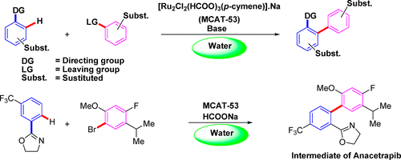
A new water friendly MCAT-53 [Ru₂Cl₂ (HCOO)₃(p-cymene)] Na (sodium η-6-p-cymene dichloro diruthenium triformato complex) has been developed as a catalyst to effect aromatic C–H bond activation and C–C coupling reactions in water. Cross-coupling reactions were performed in DI/distilled water under air- and ligand-free conditions without further activation of the catalyst. Synthesis of an advanced intermediate of CETP inhibitor, Anacetrapib, in water has been demonstrated to give a single regioisomer using the MCAT-53 catalyst.
Keywords: C−C coupling; C−H activation; MCAT-53; ruthenium catalyst

