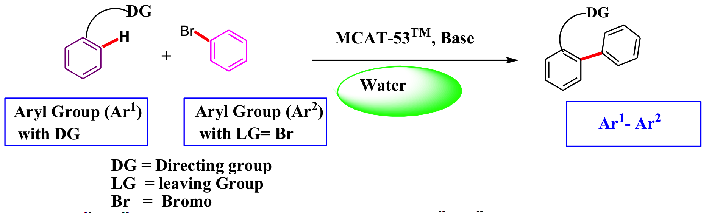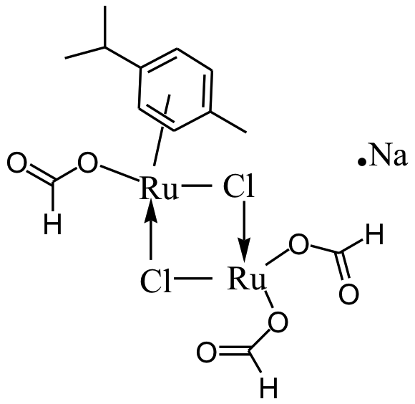****

This air-stable and bench-stable catalyst, MCAT-53 has been tested for carbon - carbon bond formation in water on substrates such as aryl oxazolines, benzoquinolines and phenyl pyridines (see reference-3). These are core building blocks for pharmaceuticals and agro-chemicals.



Bromides, chlorides and heavily sub-stituted halides can work smoothly under the catalytic conditions. Some of the examples are given below:

 **-**

This first of its class, bench- and air-stable, MCAT-53™ will find wide utility in cost-effective and greener alternatives in pharmaceutical and manufacturing processes.

Please contact us for more information about MCAT-53 catalyst.

Traditional metal- catalyzed cross-coupling reactions are regularly conducted in polar, aprotic solvents such as N-methylpyrrolidinone (NMP), dimethylformamide (DMF) or dimethylacetamide (DMAc) (1, 2). These solvents are undesirable because of their toxicity and disposal costs.

MCAT-53TM is a ruthenium based solid air stable catalyst that has been recently discovered by the scientists of Chicago Discovery Solutions LLC., USA. It has been tentatively assigned as having chemical formula as Ru2Cl2(p-cymene) (HCOO)2. HCOONa or Ru2Cl2(p-cymene) (HCOO)3Na.

In contrast to Pd and other metal catalyzed C-H activated C-C coupling reactions, ruthenium based MCAT-53 achieves C–H-activated C–C coupling in water under ligand-free conditions, requiring no oxidants (such as copper (II) salts and silver (I) salts, or benzoquinone) and no acid. The catalyst is tailor made to work in DI/ distilled water. Only a base such as potassium carbonate may be occasionally required.

**Figure - 1**

Bromides, chlorides and heavily substituted halides can work smoothly under the catalytic conditions. Some of the examples are given below (see figure-2):



Contact us for more information and/or assistance with improving your research program.

MCAT-53 is now available for R&D purposes at **Aldrich**. (Aldrich Catalogue number 900285).

**-No acid**

**-No co-solvent**

**-No surfactant**

**-No oxidants**

**-No ligands**

MCAT-53

# **Chicago Discovery Solutions’ proprietary and patented catalyst MCAT-53 TMi is made for CH activated C-C coupling reactions. No need to add acid, co-solvent, surfactant, oxidants or ligands or perform additional steps for activation of the catalyst.**

# **MCAT-53™ Catalyst**

# **The catalyst that takes Green Chemistry to a new level.**

# **An Efficient and versatile Ru formato catalyst for C-C coupling in water.**

3.PCT application PCT application WO / US 2014/059281,

2. Constable et al. *Green Chem*., 2007, 9, 411-420.

1. Fischmeister and Doucet. *Green Chem.*, 2011, 13, 741-753.

## References

### Chicago discovery solutions

23561 W. Main Street  
Plainfield, IL 60544

### Phone

815-609-2071

### Web

Chicagodiscoverysolutions.com

sales@chicagodiscoverysolutions